Question 1:

Run the Basis functions related code shared in the “Basis.py” file [Points 50]

– Explain Piecewise constant fit.

Use the mean of the y value in each region as the constant fit.

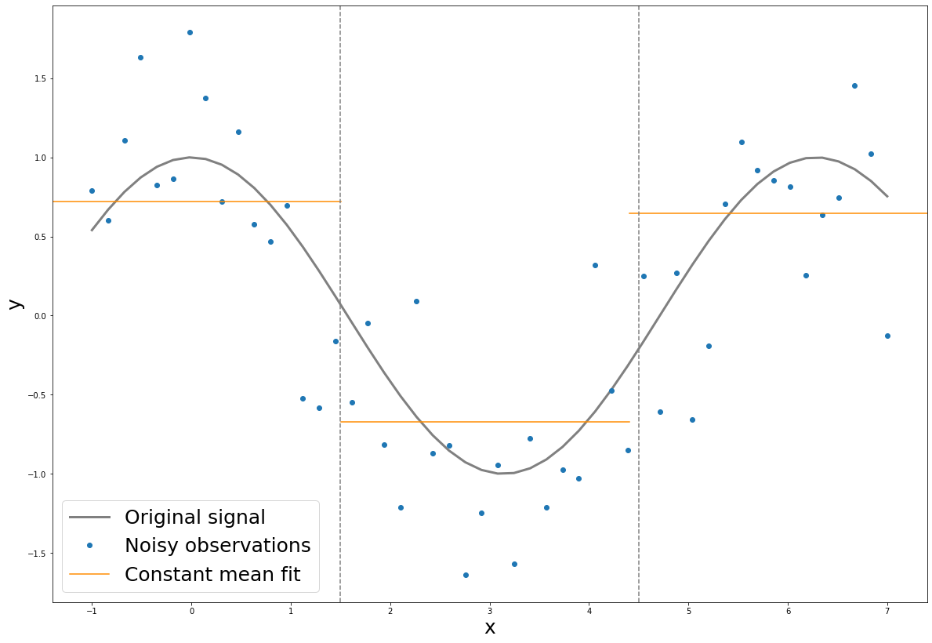

– Explain Piecewise linear fit.

Add first-degree polynomials in each region and use the ordinary least square error to find the weight for each region.

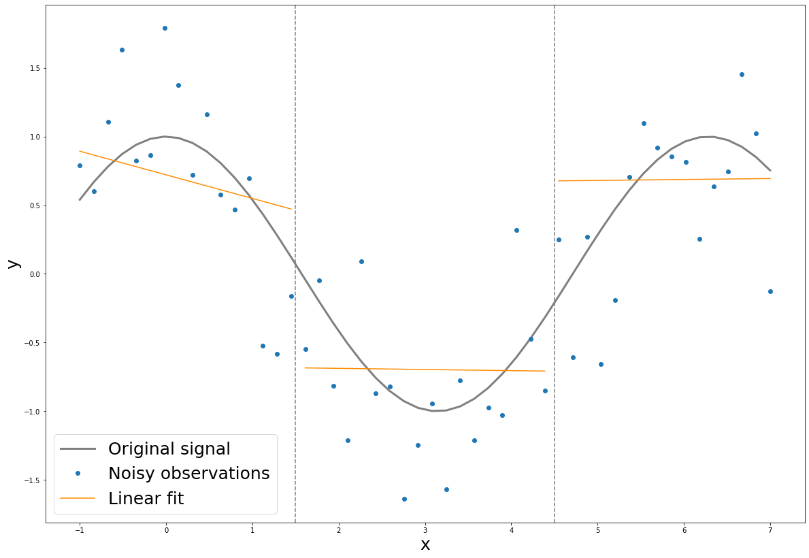

– Explain Continuous Piecewise Linear.

Because we divide the x into three regions, we have 2 knots and we want our fitted function to be continuous at each knot. So we have which will yield ⇒. The same logic applies to knot 2 which yield . So we decrease 6 parameters to 4 in continuous versio which is

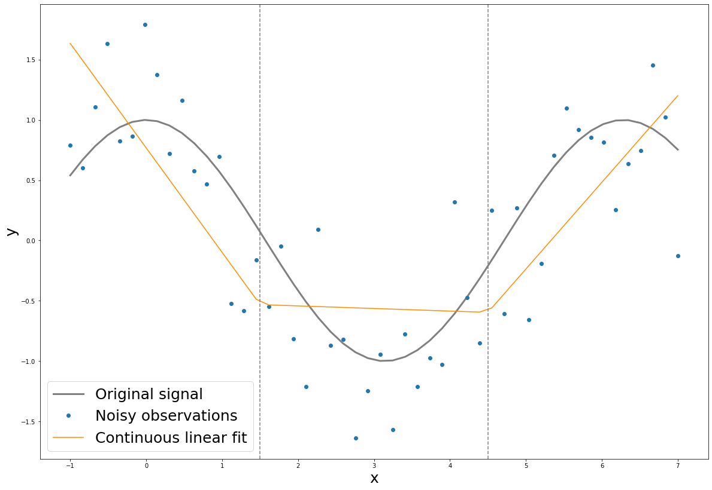

– Explain Continuous cubic spline fit.

In this case, we fit 3rd-degree polynomials in each region and we make sure that at each knot the function has the same value, first degree derivative value and second degree derivative to ensure the function is continuous.

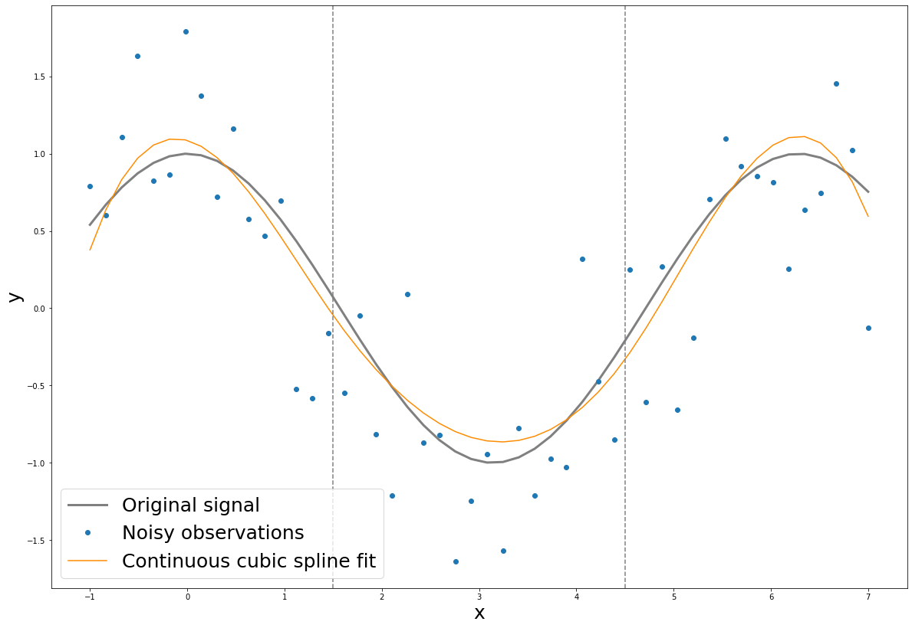

Question 2:

Run the Basis functions related code shared in the “Basis.py” file for the ”WholeFood.xlsx” data: [Points 50]

– Explain Piecewise constant fit.

Use the mean of the y value in each region as the constant fit.

| Region1 Mean | 23.764 |
| --- | --- |
| Region2 Mean | 28.346 |
| Region3 Mean | 36.864 |

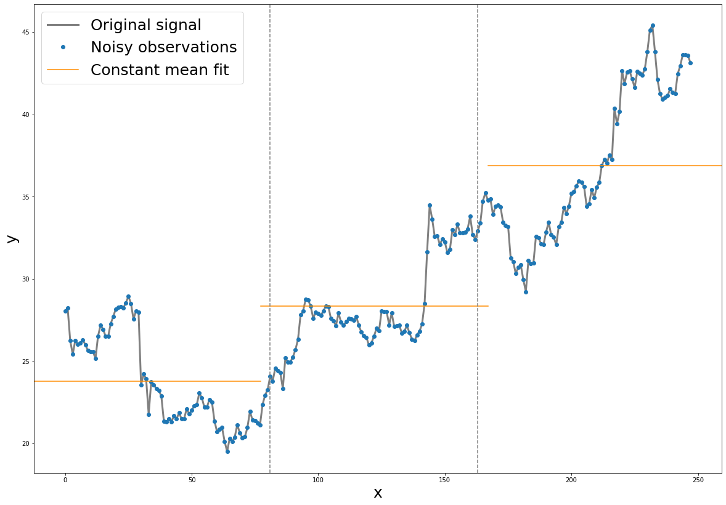

– Explain Piecewise linear fit.

Add first-degree polynomials in each region and use the ordinary least square error to find the weight for each region.

| Region1 Beta | -0.0234 |
| --- | --- |
| Region2 Beta | 0.00321 |
| Region3 Beta | 0.00227 |

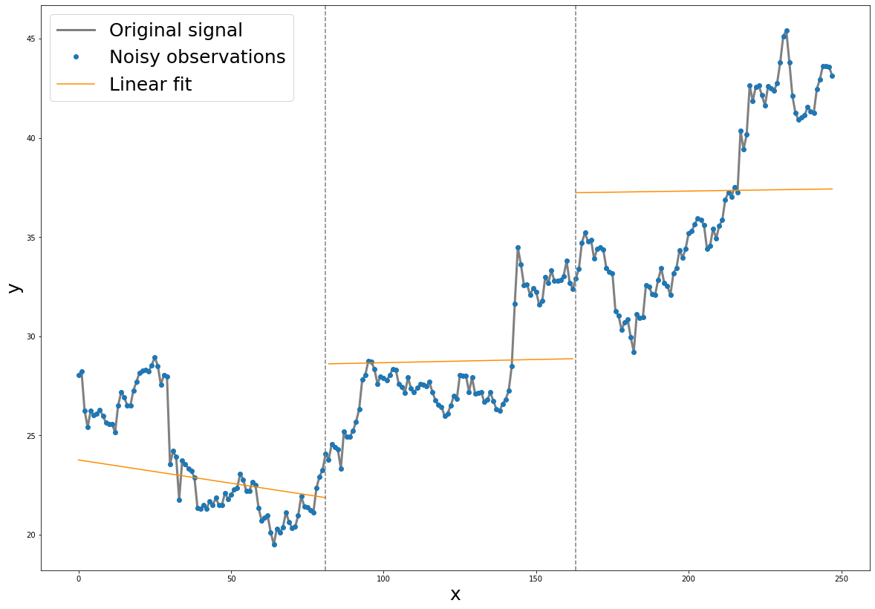

– Explain Continuous Piecewise Linear.

Because we divide the x into three regions, we have 2 knots and we want our fitted function to be continuous at each knot. So we have which will yield ⇒. The same logic applies to knot 2 which yield . So we decrease 6 parameters to 4 in continuous versio which is .

With the constraints, the function can capture the general trend of this time-series data.

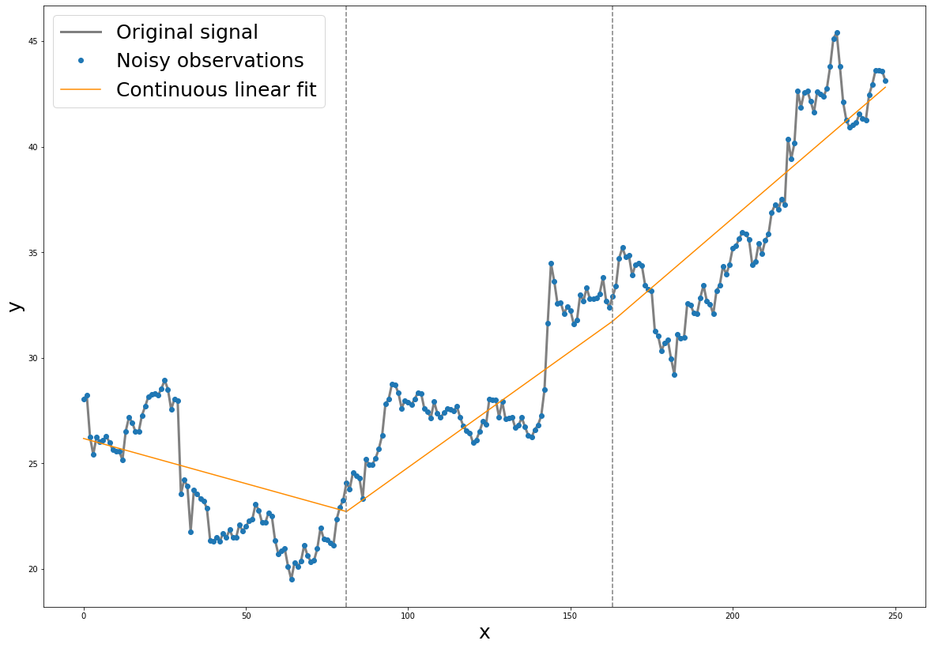

– Explain Continuous cubic spline fit is not a good fit for this data.

Compared to the Continuous Piecewise Linear, the Continuous cubic spline fit only captures the general trend and very few patterns in each region. Still, the fitted function loses much information about the seasonality because we have a limited number of degrees. Also, the function does not perform well in capturing the pattern around the knots especially at knot2.

